Local Authority Sites: Example enforcement script

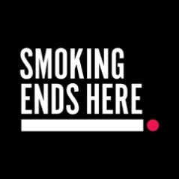


Starting the Conversation
Staff Member:
Hi there, I just wanted to let you know that all Local Authority sites are completely smokefree. That includes both inside buildings and all outdoor areas such as entrances, car parks, and grounds.
Smoker:
Oh, I didn’t realise / I’m just having a quick one.
Staff Member:
Thanks for understanding. To protect the health of staff, visitors, and the public, we ask that you please put out your cigarette or vape. If you do wish to continue smoking, you’ll need to move off-site to do so.

If the smoker challenges the request
Smoker:
Why can’t I smoke here? I’m outside.
Staff Member:
I understand it might seem okay, but the smokefree policy applies to all areas of the site, indoors and outdoors. It’s part of our commitment to creating a healthier environment for everyone.
Smoker:
I’m trying to quit / It’s hard to stop.
Staff Member:
That’s completely understandable, quitting is difficult. There’s free support available through our local stop smoking services, including advice, nicotine replacement therapies, and tailored help. If you’d like, I can show you where to find more information and support.

Closing the conversation
Staff Member:
Thanks again for your cooperation. If you’d like help accessing support to quit, I’d be happy to point you in the right direction. And just a reminder, if you do need to smoke, please do so off-site.

