NHS Smokefree Sites – Example enforcement Script for NHS Trust sites and Settings
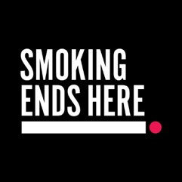


Starting the Conversation
Staff Member:
Hi there, I just wanted to let you know that all NHS sites, including these hospital grounds are completely smokefree – that includes both inside buildings and all outdoor areas such as entrances and carparks.
Smoker:
Oh, I didn’t realise / I’m just having a quick one.
Staff Member:
I understand and thank you for listening. The smokefree policy is in place to protect the health of patients, staff, and visitors. We kindly ask that you put out your cigarette out now. If you do wish to continue smoking, you’ll need to move off-site to do so.
If the smoker challenges the request
Smoker:
Why can’t I smoke here? I’m outside.
Staff Member:
I understand it might seem okay, but the smokefree policy applies to all areas of the site, indoors and outdoors. It’s part of our commitment to creating a healthier environment for everyone.
Smoker:
I’m trying to quit / It’s hard to stop.
Staff Member:
That’s completely understandable, quitting smoking is tough, but there is support available. You can buy nicotine replacement alternatives from hospital shops, and we have Quit Zones on site where you can use vapes as an alternative to smoking. There are also free resources and support available through local stop smoking services. You can also scan the QR code on the smokefree posters around the site for instant access to support options.
Closing the conversation
Staff Member:
Thanks for your understanding and for helping us keep the site smokefree. If you’d like help finding a Quit Zone or accessing support, I’d be happy to point you in the right direction. And just a reminder, if you do need to smoke, please do so off-site.

